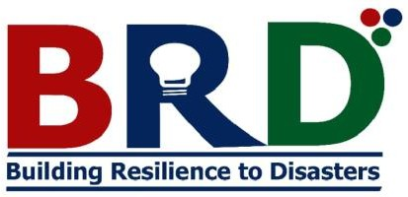

BRD Tanzania

Organizational Profile

BRD TANZANIA AT-A-GLANCE

Name of the Organization: | Building Resilience to Disasters (BRD Tanzania)
Type of the Organization: | Non-Governmental Organization (NGO)
Country: | Tanzania
Address of the Organization: | DERM House, 7th floor, Bagamoyo road, P. O. Box 6548, Dar es Salaam, Tanzania
Website of the Organization: | https://brd.or.tz/
Email Address: | info@brd.or.tz,
Date of Establishment: | 7th March 2022
Date of Registration: | 14th July 2022
Registration Number: | ooNGO/R/3470
Registered under Act: | Non-Governmental Organization Act 2002
Contact person: | Name: Ms. Vivaoliva U. Shoo Mobile Phone: 255 789 932878 Email: vivaoliva.shoo@brd.or.tz  /vivaoliva12@gmail.com
Organization focus areas: | Disaster Risk Management(DRM)/Disaster Risk Reduction(DRR), Climate change, Geospatial and Earth Observation Technologies, Education, Health,  and Environment
Bank account information | Account name: BRD Tanzania Account number: 0150687679600  Bank Name: CRDB Bank, Kijitonyama Branch Dar es Salaam

BACKGROUND

Tanzania has been facing a number of disasters caused by natural and human induced hazards such as floods, drought, earthquake, tropical cyclones, strong winds, landslides, accidents, and epidemics that affect lives of the people and cause economic losses and health problems. In recent years, there has been unprecedented increase of occurrences, intensity and impacts of disasters particularly weather-related disasters due to climate change. Climate change augments and intensifies risks of disasters such as floods and droughts.
Managing and reducing disaster risks is central to saving lives, protecting properties and livelihoods and ensuring sustainable development. In this regard, Building Resilience to Disasters (BRD) Tanzania is committed to building safe and resilient communities to disasters and promoting disaster risk reduction awareness to vulnerable communities. It is further dedicated to advancing scientific knowledge, policy and practice on disaster risk management (DRM) and Disaster risk reduction (DRR). Furthermore, BRD focuses on developing innovative and sustainable geospatial solutions to manage disaster risks for sustainable development.

OUR ORGANIZATION

BRD Tanzania is an independent, non-governmental and not-for-profit organization registered in Tanzania in 2022 with registration No. ooNGO/R/3470. BRD Tanzania is a national Non-Governmental Organization that operates in Tanzania Mainland.

GOAL, MISSION AND VISION

Our Goal
To reduce disaster risks and build safe and resilient communities to disasters for sustainable development and climate resilient.

Our Mission
To be the leading organization dedicated to the discovery, innovation, and development of evidence based solutions to address the challenges of disaster impacts and build disaster resilient communities.

Our Vision
To foster the use of new technologies and scientific information to practitioners and policy makers to improve community capacities in addressing the challenges of disasters in vulnerable communities.

Our Strategy
To engage and work together with vulnerable communities to build their capacities and strengthen their resilience to prepare for, respond to, and recover from disasters.

OUR SERVICES
Our professional services which we offer include research, training and consultancy services pertaining to disaster risk management (DRM) and disaster risk reduction (DRR) issues and the applications of geospatial and earth observations technologies in DRM and DRR. The services which we offer are organized and managed by three centers: BRD research center, BRD consultancy and advocacy center and BRD Training center.

Research Services

Research services are offered and administered by BRD Research Center. Our research focuses on, among others, the following research thematic areas: Hazard Prevention and Mitigation; Disaster Preparedness; Disaster Response; Disaster rehabilitation and Recovery; disaster resilience; Disaster Risk assessment; Vulnerability Assessment (physical, social, political and economic vulnerability); Disaster Governance; Gender and disaster risk reduction; Early warning; and Climate change mitigation and Adaptation.

Consultancy Services

Our consultancy and advocacy services are coordinated by BRD Consultancy and Advocacy Center. We offer professional consultancy services to the general public in several thematic areas: Applications of Geographic Information Systems (GIS) and remote sensing in disaster risk management; Mapping services; developing of geospatial tools and solutions for DRM and DRR; Developing of Disaster Risk Management and Disaster risk reduction strategies; Developing of Climate change adaptation and mitigation strategies; conducting climate change risk assessments;
Other services include Development of emergency operation plan(EOP), Emergency Preparedness and Response Plan(EPRP), Development of hazard mitigation plans (HMP), Disaster recovery plan (DRP), Risk Communication

Plan(RCP),and Crisis management plan(CMP); Conducting vulnerability assessments; Developing emergence operational and communication Center(EOCC); Data collection and analysis for disaster risk management; Developing disaster risk management policies and Acts; Humanitarian assistance to disaster victims; Post-disaster needs assessment and analysis ; and Refugee operations and environmental management.

Training Services

Training services are offered and managed by the BRD Training Center. Our training programmes aim at improving risk knowledge and awareness on DRM/DRR among residents living in vulnerable communities. We conduct training programmes on disaster risk management and the application of geospatial science and technology.

Our training focus on the following thematic areas: Hazard mitigation, disaster preparedness, response and recovery; Climate change adaptation and mitigation; Climate change risk assessments; Geographical information system (GIS) and Remote sensing; Environmental hazards; Mapping services; Developing Disaster Risk Management and Disaster risk reduction strategies, Climate change adaptation and mitigation strategies, Emergency operation plan(EOP); and Emergency Preparedness and Response Plan(EPRP); Health services, Water, sanitation and hygiene(WASH); Gender-equality and empowerment of women and girls; and Community engagement

Humanitarian services and Volunteering

BRD provides emergency relief, health care and Water, Sanitation and hygiene (WASH) to disaster victims during, before, and after an emergency through national and international partnerships.

BRD volunteers are often the first to arrive and the last to leave the disaster scene. Our volunteers are part of the community they serve and are guided by national and international humanitarian standards to ensure they act with integrity at all times. To join the BRD volunteer team one needs to register as a member through BRD system and be offered a certified BRD membership card.

Outreach services

BRD Tanzania is committed to providing outreach to practitioners, policy makers and the public in general. BRD hosts a number of events annually including workshops, training and seminars to create awareness to the public towards

becoming more disaster resilient and strengthening preparedness for effective disaster response.

WORK WITH US
Joining BRD Tanzania means committing to protect and assist vulnerable communities and promoting the organization’s principle values. Applications are encouraged from all qualified candidates without distinction on the grounds of race, colour, sex, national origin, age, religion, or disability. We work with skilled professionals who are committed to put lives of people first, make a real difference in people’s lives and are willing to go anywhere we are needed to work during, before and after an emergency.

DONATE
To donate financial or in-kind resources, please contact BRD at 0768 -021-824/0789 932 878 or visit us at https://brd.co.tz/

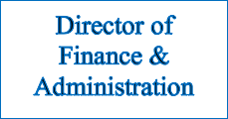
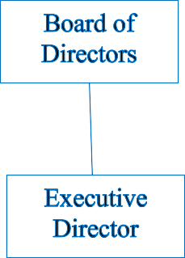
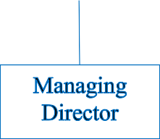
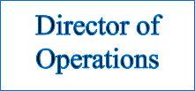
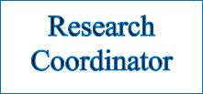
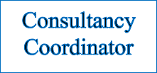
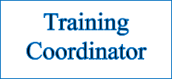
OUR ORGANIZATION STRUCTURE
Our organization is governed by a board of directors and executive management. The Board provides our organization with strategic guidance and governance while the Management leads the organization in ensuring that it achieves its strategic objectives and realizes its mission.

OUR TEAM
We are a multidisciplinary team of experts, with one goal; to save lives through creating safe and more resilient communities. Many of our experts are internationally recognized in their specialized fields: Disaster Risk Management, Climate change and adaptation, Urban Planning and Management, Geographical Information System (GIS) and remote sensing, Project management, and Monitoring and Evaluation (M&E). With such breadth of expertise, we can manage and accomplish any project pertinent to disaster risk management and climate change and adaptation.

